Consider the following information about a university database:

**CASE STUDY [IMPORTANT]**

**Question No.1**

|  |
| --- |
| * **Professors have an SSN, a name, an age, a rank, and a research specialty.** * **Projects have a project number, a sponsor name (e.g., NSF), a starting date, an ending date, and a budget.** * **Graduate students have an SSN, a name, an age, and a degree program (e.g., M.S. or Ph.D.).** * **Each project is managed by one professor (known as the project's principal investigator).** * **Each project is worked on by one or more professors (known as the project's co-investigators).** * **Professors can manage and/or work on multiple projects.** * **Each project is worked on by one or more graduate students (known as the project's research assistants).** * **When graduate students work on a project, a professor must supervise their work on the project. Graduate students can work on multiple projects, in which case they will have a (potentially different) supervisor for each one.** * **Departments have a department number, a department name, and a main office.** * **Departments have a professor (known as the chairman) who runs the department.** * **Professors work in one or more departments, and for each department that they work in, a time percentage is associated with their job.** * **Graduate students have one major department in which they are working on their degree.** * **Each graduate student has another, more senior graduate student (known as a student advisor) who advises him or her on what courses to take.** |

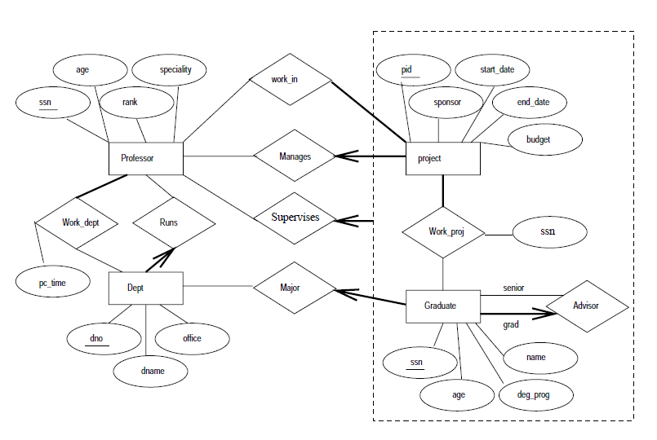

**Question No.2**

A data model is the relatively simple representation, usually graphic of complex real word data structures. It represents data structures and their characteristics, relations, constraints, and transformations. Read the scenario below carefully.

|  |
| --- |
|  |
| **The Prescriptions-R-X chain of pharmacies has offered to give you a free lifetime supply of medicine if you design its database. Give the rising cost of health care, you agree. Here’s the information that you gather.** |
|  |
| * **Patients are identified by an ID, and their names, addresses, and ages must be** |
| **recorded.** |
| * **Doctors are identified by an ID. For each doctor, the name, specialty, and years of experience must be recorded.** |
| * **Each pharmaceutical company is identified by name and has a phone number.** |
| * **For each drug, the trade name and formula must be recorded. Each drug is** |
| **sold by a given pharmaceutical company, and the trade name identified a drug** |
| **uniquely from among the products of that company. If a pharmaceutical company** |
| **is deleted, you need not keep track of its products any longer.** |
| * **Each pharmacy has a name, address, and phone number.** |
| * **Every patient has a primary physician. Every doctor has at least one patient.** |
| * **Each pharmacy sells several drugs and has a price for each. A drug could be sold** |
| **at several pharmacies, and the price could vary from one pharmacy to another.** |
| * **Doctors prescribe drugs for patients. A doctor could prescribe one or more drugs** |
| **for several patients, and a patient could obtain prescriptions from several doctors.** |
| **Each prescription has a date and a quantity associated with it.**   * **Pharmaceutical companies have long-term contracts with pharmacies. A pharmaceutical company can contract with several pharmacies, and a pharmacy can contract with several pharmaceutical companies. For each contract, you have to store a start date, an end date, and the test of the contract.** |
| **You can assume that if a doctor prescribes the same drug for the same patient more than once only the last such prescription needs to be stored.** |

